SPRINT -2

|  |  |
| --- | --- |
| Date | 5 November 2022 |
| Team id | PNT2022TMID11798 |
| Project name | Real Time River Water Quality Monitoring And  Control System |
| Maximum marks | 20 marks |

# STEP 1:

Log on to IBM cloud and create IBM Watson IOT Platform from IBM cloud Dashboard.

# STEP 2:

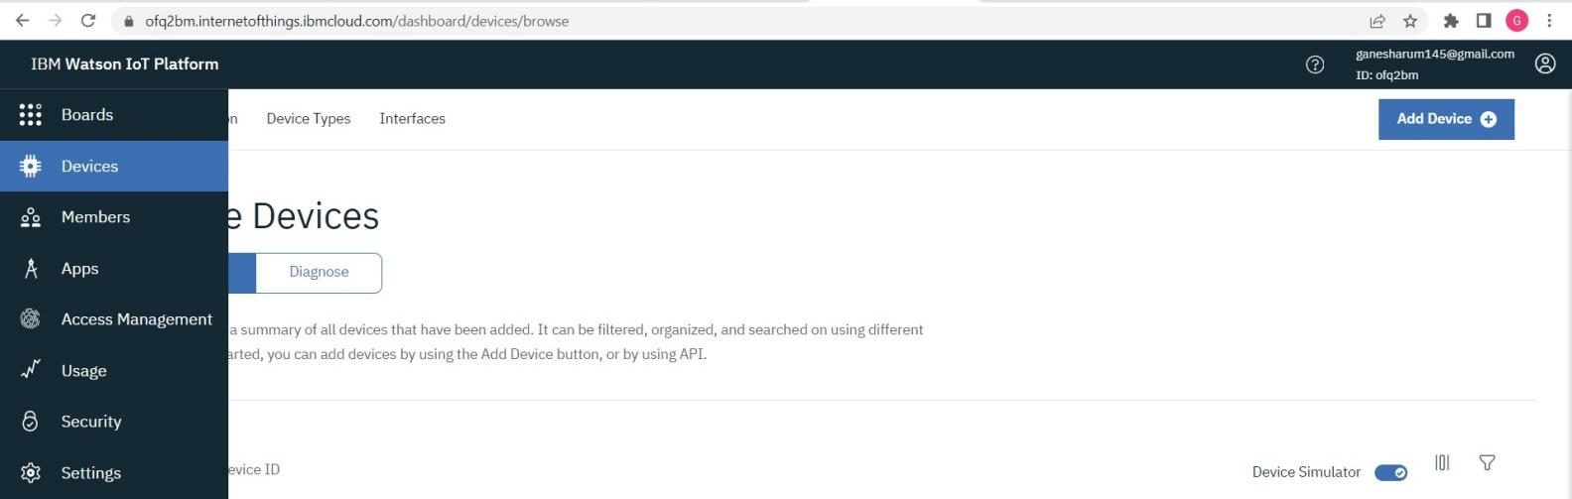After Creating IBM Watson IOT Platform,create an Organization (ex.84708c ID:

# STEP 3:

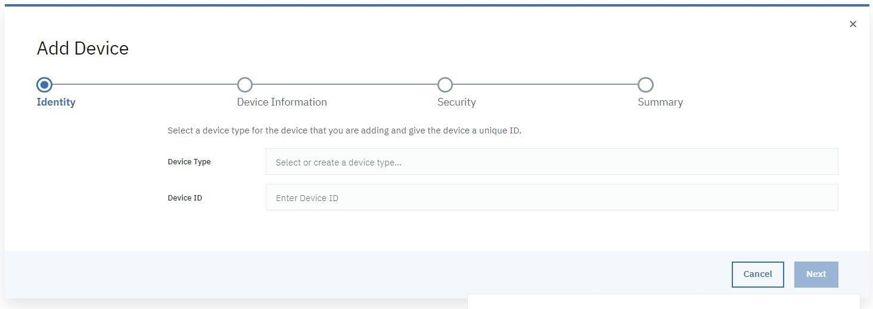Create an device IBM IOT PALTFORM.

# STEP 4:

NODE RED SERVICE

* INSTALL IBM IOT IN MANGE PALETTE. 

INSTALL NODE RED DASHBOARD.

# STEP 5:

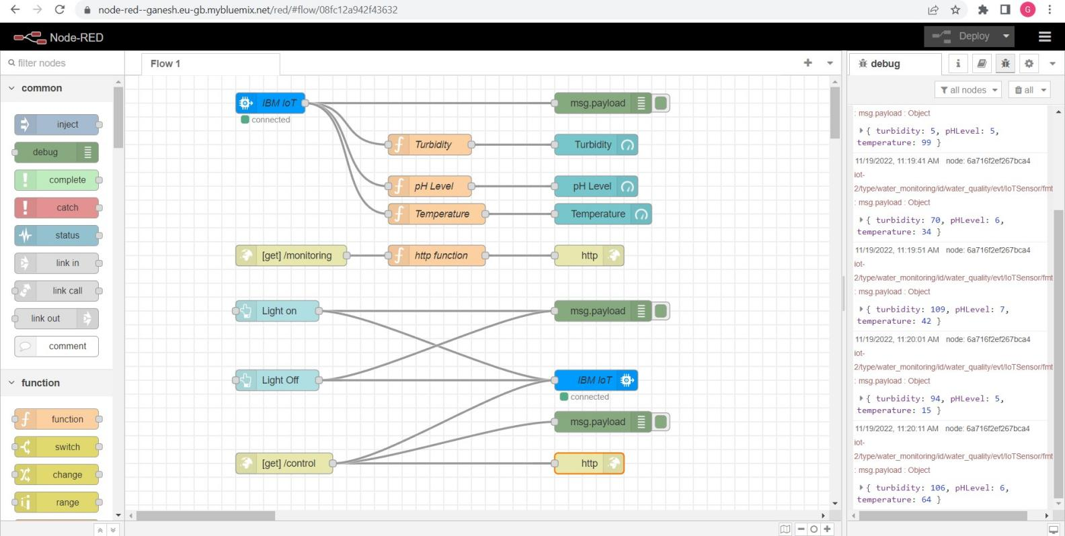**Configuring the corresponding nodes**

# STEP 6:

Deploy the Services and verify the output values.

# OUTPUT IN IBM WATSON IOT PLATFORM: